| **loja** (cnpj char (19) primary key, endereco char (200) not null, fone char (15) not null, nome char (100)); |
| --- |
| **funcionarios** (cpf char (14) primary key, **cnpj_loja** char(19) foreign key, nome char (100), data_de_inicio date not null, salario float,  **cnpj_loja** references loja(cnpj); |
| **secretario (**id_secretario int primary key); |
| **mecanico (**id_mecanico int primary key, especializacao char(50) not null); |
| **maquina (**id_maquina int primary key, categoria char(50), modelo char (50)); |
| **cliente** (cpf char (14) primary key, endereco char (200), nome char (100), telefone char (15)); |
| **aluguel** (id_aluguel int primary key, data_inicio date not null, data_fim date not null, valor float, frete float, **id_maquina** int foreign key, **cpf_cliente** char (14) foreign key,  **id_maquina** references maquina **(id_maquina)**,  **cpf_cliente** references cliente (cpf)); |

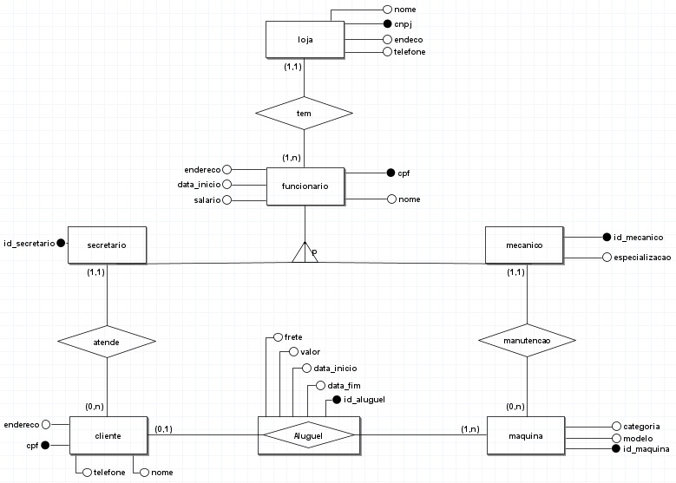

**LOJA**

| **cnpj** | **endereco** | **fone** | **nome** |
| --- | --- | --- | --- |
| 43.675.887/0001-86 | Estr. Faxinal, 1900 - Parque do Balonismo, Torres - RS, 95560-000 | (51) 94002-8922 | AlugaKi ltda |

**Funcionario**

| **cpf** | **nome** | **data_inicio** | **endereco** | **salario** |
| --- | --- | --- | --- | --- |
| 041.711.530-52 | Lorenzo Cardoso | 15/04/2018 | Av. Rio Branco, 334 - Balneário Areias Brancas, Arroio do Sal - RS, 95585-000 | 14,564 |
| 054.116.430-50 | João Manoel | 13/11/2021 | Rua Gustavo Raupp, 211 - Centro, Arroio do Sal - RS, 95585-000 | 10,895 |

**Secretário**

| **id_secretario** |
| --- |
| 57670 |

**Mecânico**

| **id_mecanico** |
| --- |
| 17635 |

**Cliente**

| **cpf** | **endereco** | **fone** | **nome** |
| --- | --- | --- | --- |
| 548.964.382-02 | Estr. Faxinal, 1900 - Parque do Balonismo, Pindamonhangaba - SP, 12400 | (12) 99862-4207 | Natan Mota C. |
| 975.789.114-07 | Rua das Limeiras, 1874 - Igrejinha, Santa Bárbara d’Oeste - SP, 13450-001 | (19) 98754-4782 | Antonio Marcos |
| 874.998.514-89 | Av Brigadeiro Faria Lima, 3477, Itaim Bibi, São Paulo - SP,04538-133 | (11) 99842-1475 | Fulano dos Santos |

.

**Máquina**

| **id_maquina** | **modelo** | **categoria** |
| --- | --- | --- |
| 25406 | Betoneira | Construção |
| 87325 | Motocultivador | Agrícola |
| 95621 | Serra circular | Ferramenta |
| 54823 | Furadeira de impacto | Ferramenta |
| 82459 | Motosserra | Agrícola |
| 64658 | Andaimes | Construção |

**Aluguel**

| **id_aluguel** | **data_inicio** | **data_fim** | **valor** | **frete** | **id_maquina** | **cpf_cliente** |
| --- | --- | --- | --- | --- | --- | --- |
| 59847 | 18/06/2022 | 24/06/2022 | 150,00 | 80,00 | 95621 | 874.998.514-89 |
| 87325 | 17/05/2022 | 23/05/2022 | 165,00 | 60,00 | 64658 | 548.964.382-02 |
| 78978 | 16/04/2022 | 22/05/2022 | 150,00 | 65,00 | 82459 | 975.789.114-07 |